Assignment – 11.4

Write a pig script to find the count of each Hashtag in the dataset.

CODE 1:

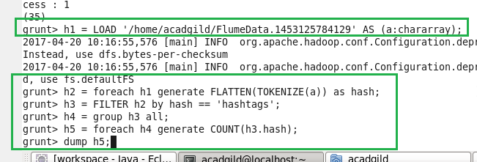

Output :

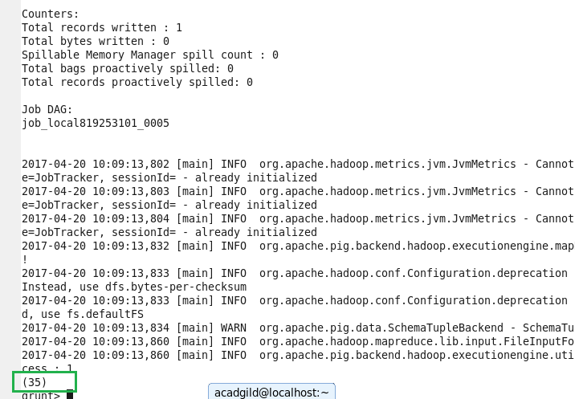

CODE 2:

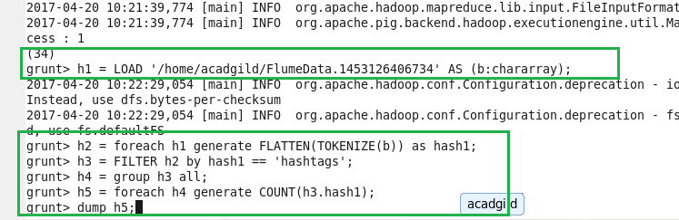

OUTPUT :

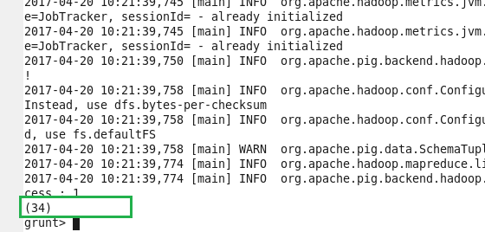

CODE 3:

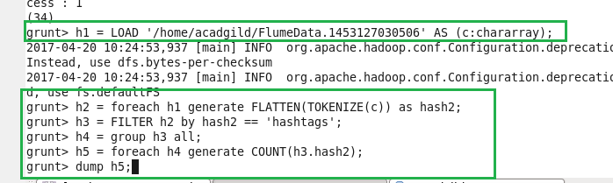

OUTPUT :

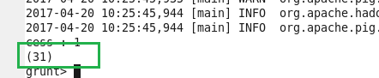

CODE 4:

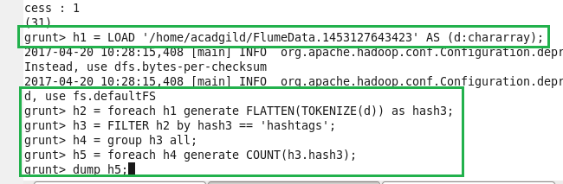

OUTPUT :

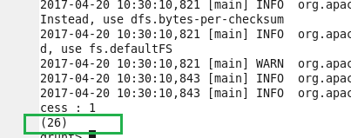

CODE 5:

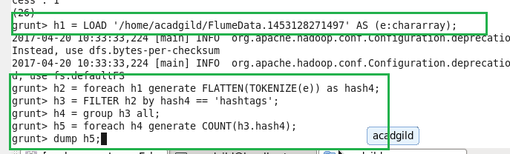

OUTPUT :

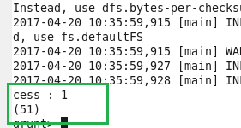

CODE 6:

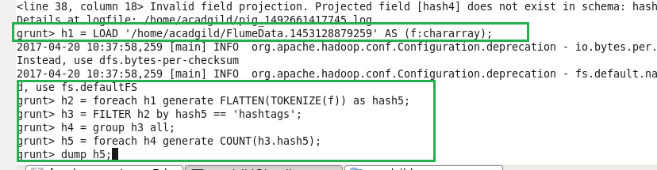

OUTPUT :

